TP1

# Exercice 1

SELECT * FROM (

SELECT ENAME, JOB, SAL FROM SCOTT.EMP WHERE SAL > (

SELECT AVG(SAL) FROM SCOTT.EMP

) ORDER BY SAL

) WHERE rownum = 1;

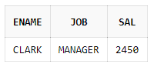

SELECT ENAME FROM SCOTT.EMP WHERE HIREDATE < (

SELECT HIREDATE FROM (

SELECT ENAME,HIREDATE FROM SCOTT.EMP WHERE DEPTNO = (

SELECT MIN(DEPTNO) FROM (

SELECT DEPTNO,COUNT(EMPNO) FROM SCOTT.EMP GROUP BY DEPTNO

)

) ORDER BY HIREDATE

) WHERE rownum = 1

);

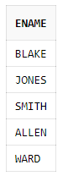

1. Je n'ai pas trouvé.
2. SELECT ENAME, EMPNO FROM SCOTT.EMP e WHERE NOT EXISTS (

SELECT MGR FROM SCOTT.EMP WHERE e.EMPNO = MGR

);

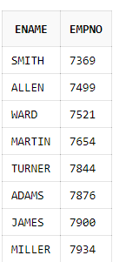

1. SELECT COUNT(*) FROM SCOTT.EMP WHERE

MONTHS_BETWEEN(TO_DATE('31/12/1999','DD/MM/YYYY'),hiredate)>222;  
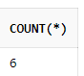

# Exercice 2

1. SELECT ROUND(MAX(salary),0) "Salaire_Maximum",

ROUND(MIN(salary),0) "Salaire_Minimum",

ROUND(SUM(salary),0) "Salaire_Cummulé",

ROUND(AVG(salary),0) "Salaire_Moyen"

FROM HR.EMPLOYEES;  
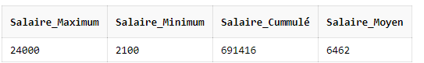

1. SELECT JOB_ID,

ROUND(MAX(SALARY),0) "Salaire_Maximum",

ROUND(MIN(SALARY),0) "Salaire_Minimum",

ROUND(SUM(SALARY),0) "Salaire_Cummulé",

ROUND(AVG(SALARY),0) "Salaire_Moyen"

FROM HR.EMPLOYEES

GROUP BY JOB_ID;  
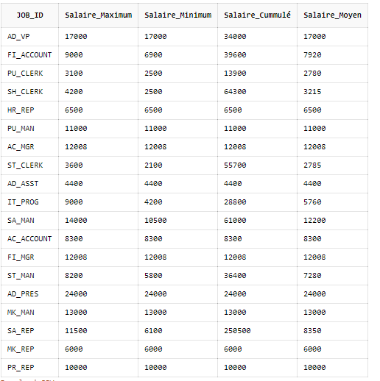

1. SELECT MANAGER_ID,MIN(SALARY) FROM HR.EMPLOYEES

WHERE SALARY is not null AND MANAGER_ID is not null AND SALARY > 6000

GROUP BY MANAGER_ID ORDER BY MIN(SALARY) DESC;  
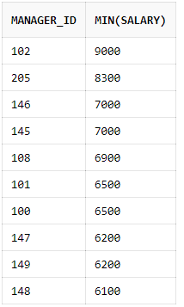

1. SELECT last_name,TO_CHAR(hire_date, 'DD-MON-YY') HIRE_DATE, TO_CHAR(hire_date, 'DAY') DAY

FROM HR.EMPLOYEES ORDER By Day ;  
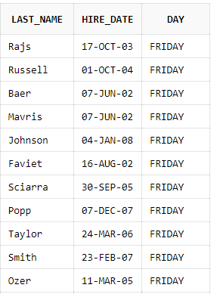

…

1. Attention, erreur dans le sujet, les dates sont 2005, 2006, 2007, 2008 car il n'y a pas d'embauche avant 2001 si on regarde rapidement les premières lignes de la base de données, et si on fait quand même la requête avec les années 1990s, le résultat est 0 pour chaque colonne.

SELECT COUNT(HIRE_DATE) as "Nombre_total_d'employés",

SUM(DECODE(EXTRACT (year FROM HIRE_DATE),'2005',1,0)) as "2005",

SUM(DECODE(EXTRACT (year FROM HIRE_DATE),'2006',1,0)) as "2006",

SUM(DECODE(EXTRACT (year FROM HIRE_DATE),'2007',1,0)) as "2007",

SUM(DECODE(EXTRACT (year FROM HIRE_DATE),'2008',1,0)) as "2008"

FROM HR.EMPLOYEES;  
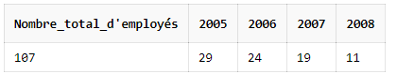

1. SELECT

e.LAST_NAME,

e.HIRE_DATE

FROM HR.EMPLOYEES e WHERE e.HIRE_DATE > (

SELECT HIRE_DATE FROM HR.EMPLOYEES WHERE LAST_NAME = 'Davies'  
);

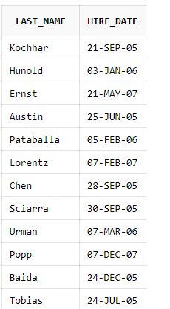  
…

1. SELECT

e.LAST_NAME,

e.HIRE_DATE,

m.LAST_NAME as "manager_LAST_NAME",

m.HIRE_DATE as "manager_HIRE_DATE"

FROM HR.EMPLOYEES e JOIN HR.EMPLOYEES m ON e.MANAGER_ID = m.EMPLOYEE_ID   
WHERE e.HIRE_DATE < m.HIRE_DATE;  
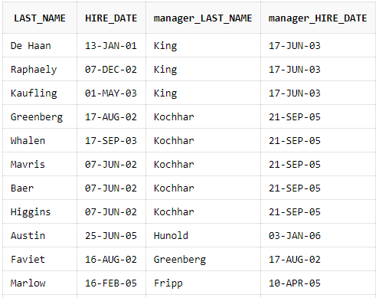  
…

1. SELECT LAST_NAME, FIRST_NAME FROM HR.EMPLOYEES   
   WHERE LAST_NAME LIKE 'Ki%' OR LAST_NAME LIKE 'Ko%';  
   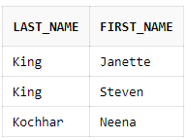
2. SELECT REPLACE(STREET_ADDRESS, ' ', '') AS STREET_ADDRESS_ FROM HR.LOCATIONS;  
   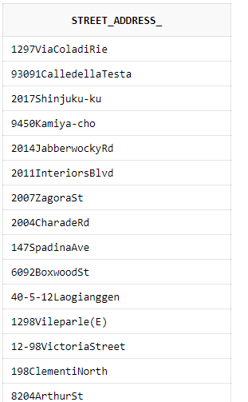  
   …
3. SELECT REPLACE(STREET_ADDRESS, 'St', 'Street') "Street_ADDRESS" FROM HR.LOCATIONS

WHERE STREET_ADDRESS LIKE '%St%' AND STREET_ADDRESS NOT LIKE '%Street%';  
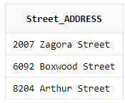

1. CREATE TABLE Contact(

l_name varchar(30),

p_number varchar(30),

CONSTRAINT valid_phone_number

CHECK (REGEXP_LIKE(p_number, '^0d{9}|d{10}$'))

);